**Test Driven Development**

We decided to choose the unit test to get the latitude and the longitude of a zip code as this was a crucial element in regards to the implementation of the map.

**TDD Roadmap**

* Tests will be made when there is a functionality we want to implement
* Run the tests to see them fail
* Produce the minimum amount of code required to pass the test
* Run the tests again to see them pass
* Refactor new code to improve the functionality
* Rerun tests again to ensure they all pass

We created unit tests to correspond with our user stories. If there were any user stories created or adjusted in the Sprint Backlog we would make a unit test for them. For tests that passed, a small part of the code would be refined or improved before running the unit tests again to ensure so that that any major issues in the code will be significantly reduced. This resulted in cutting down additional efforts in the overall development process and helped fixed issues much faster than traditional development.

**Distance Calculator Testing**

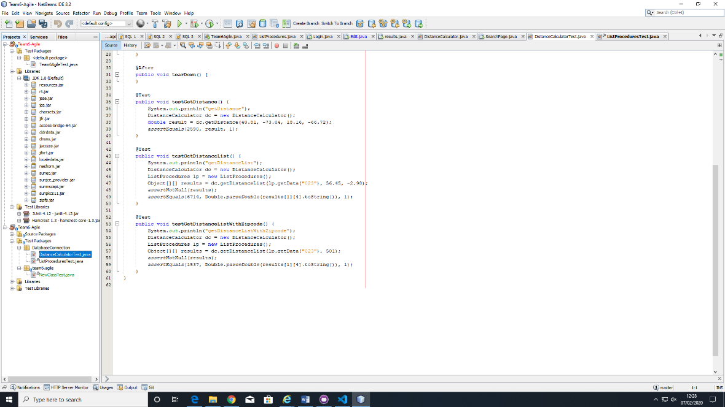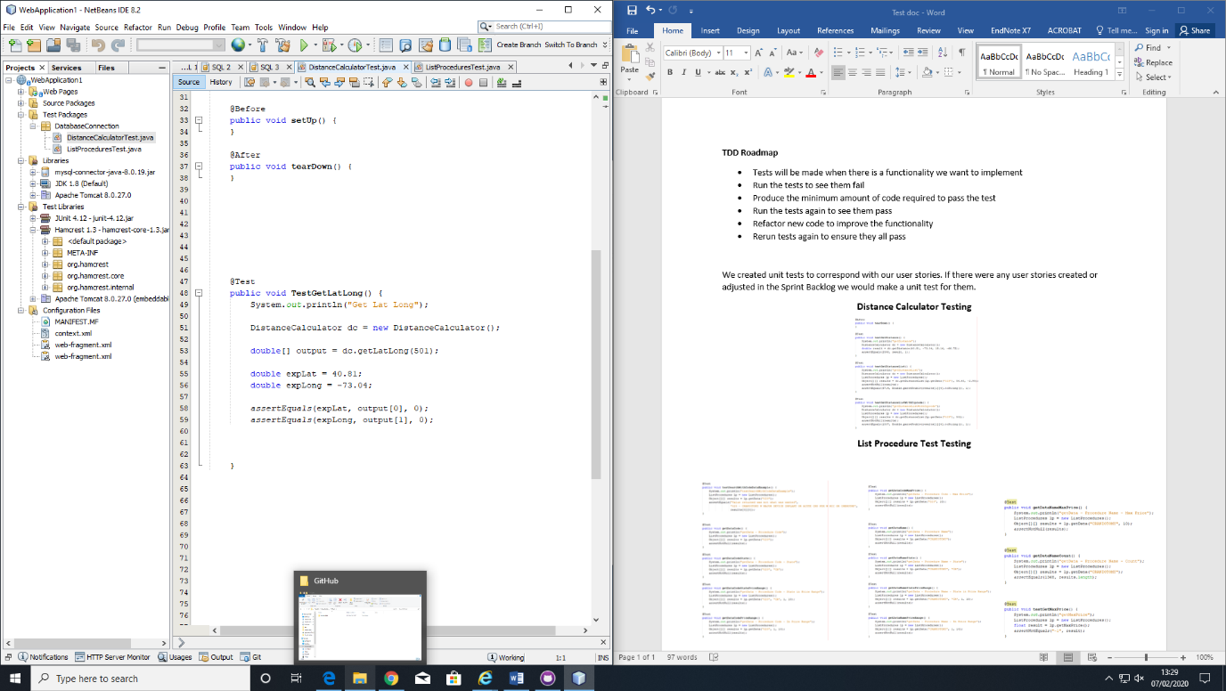

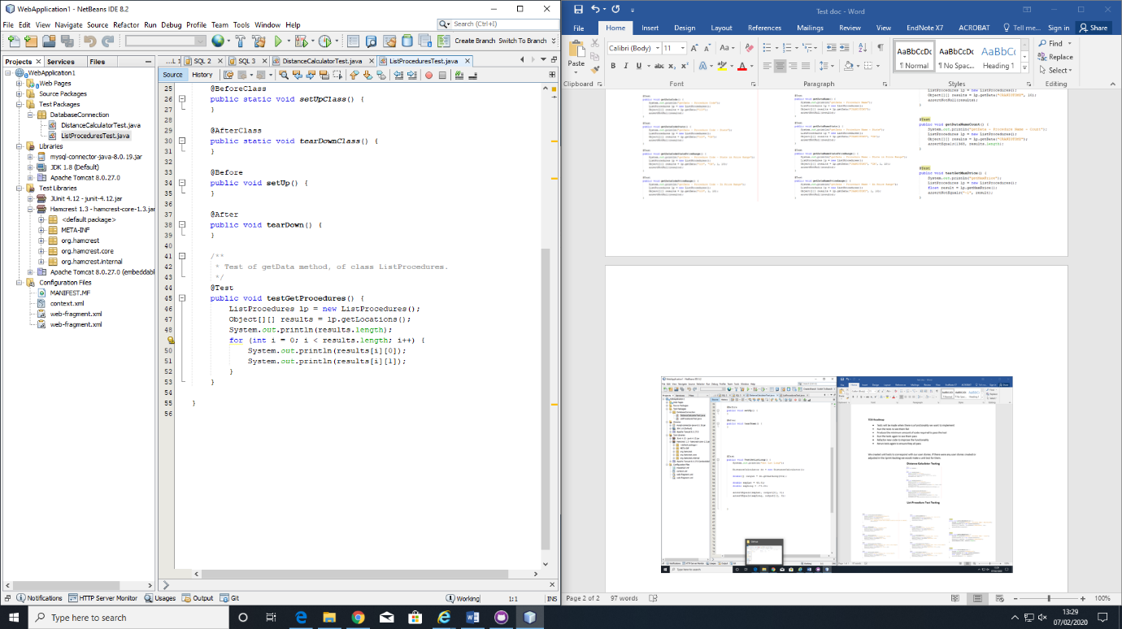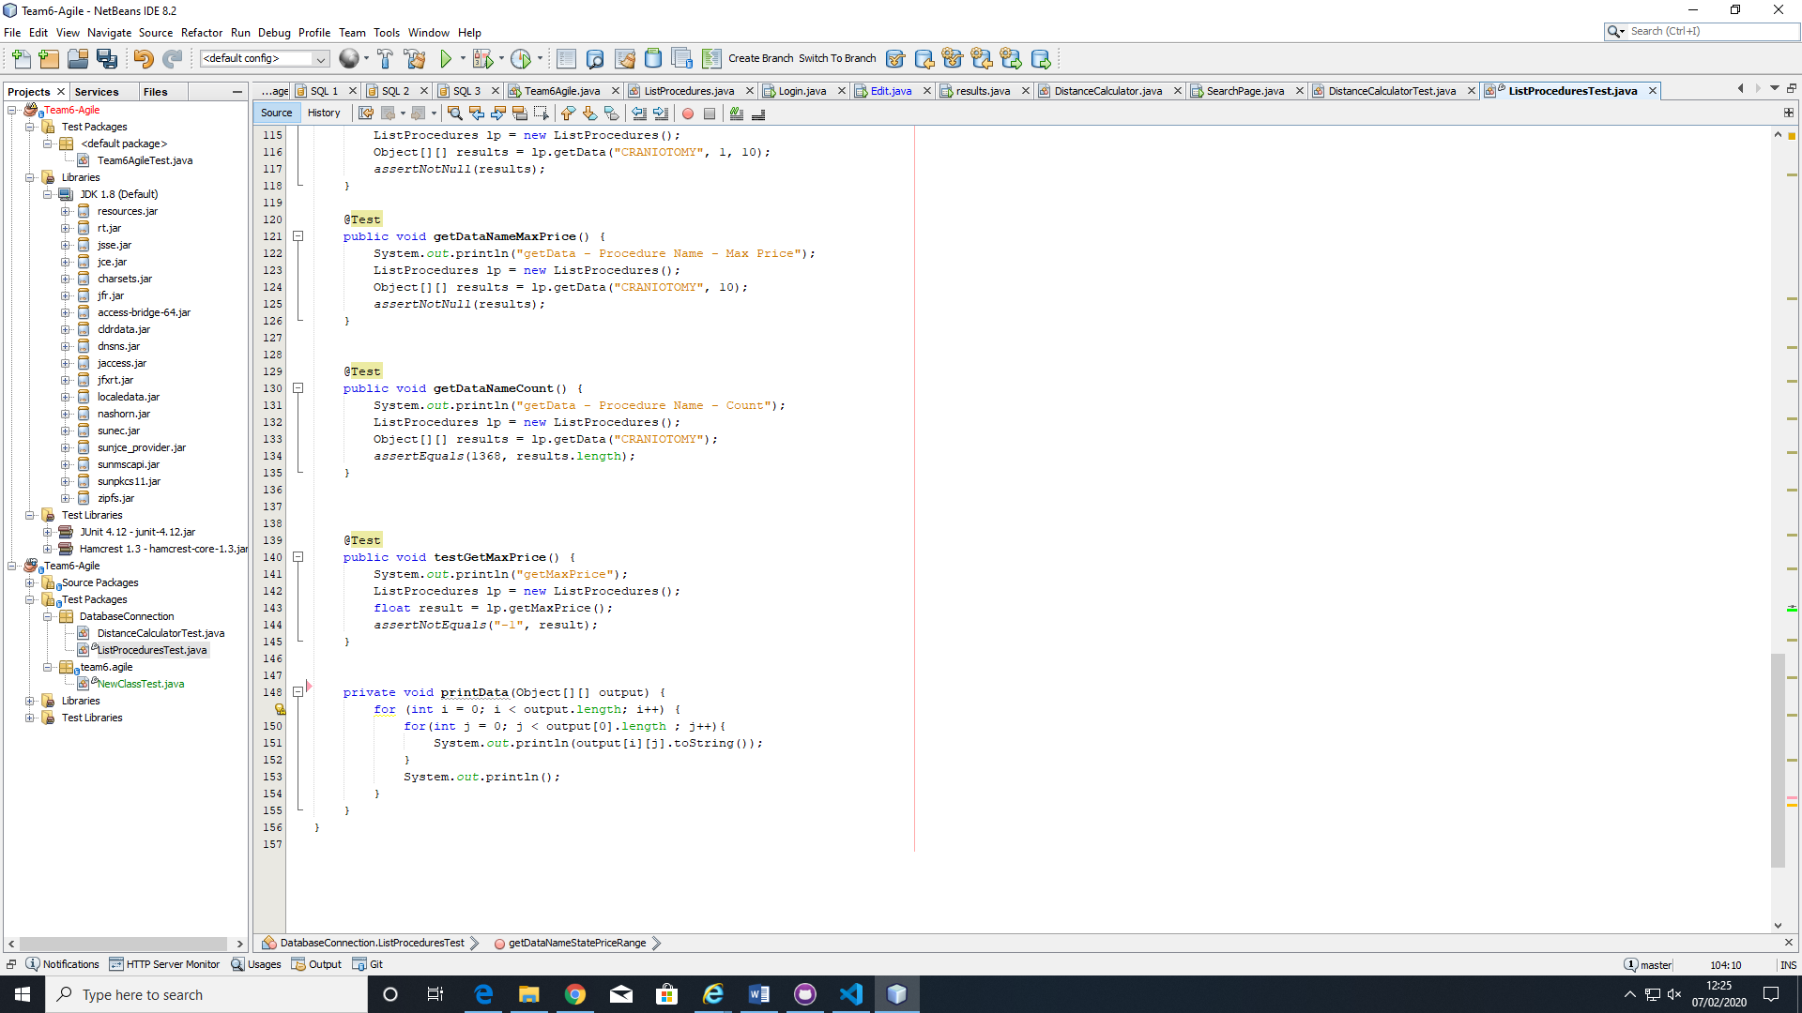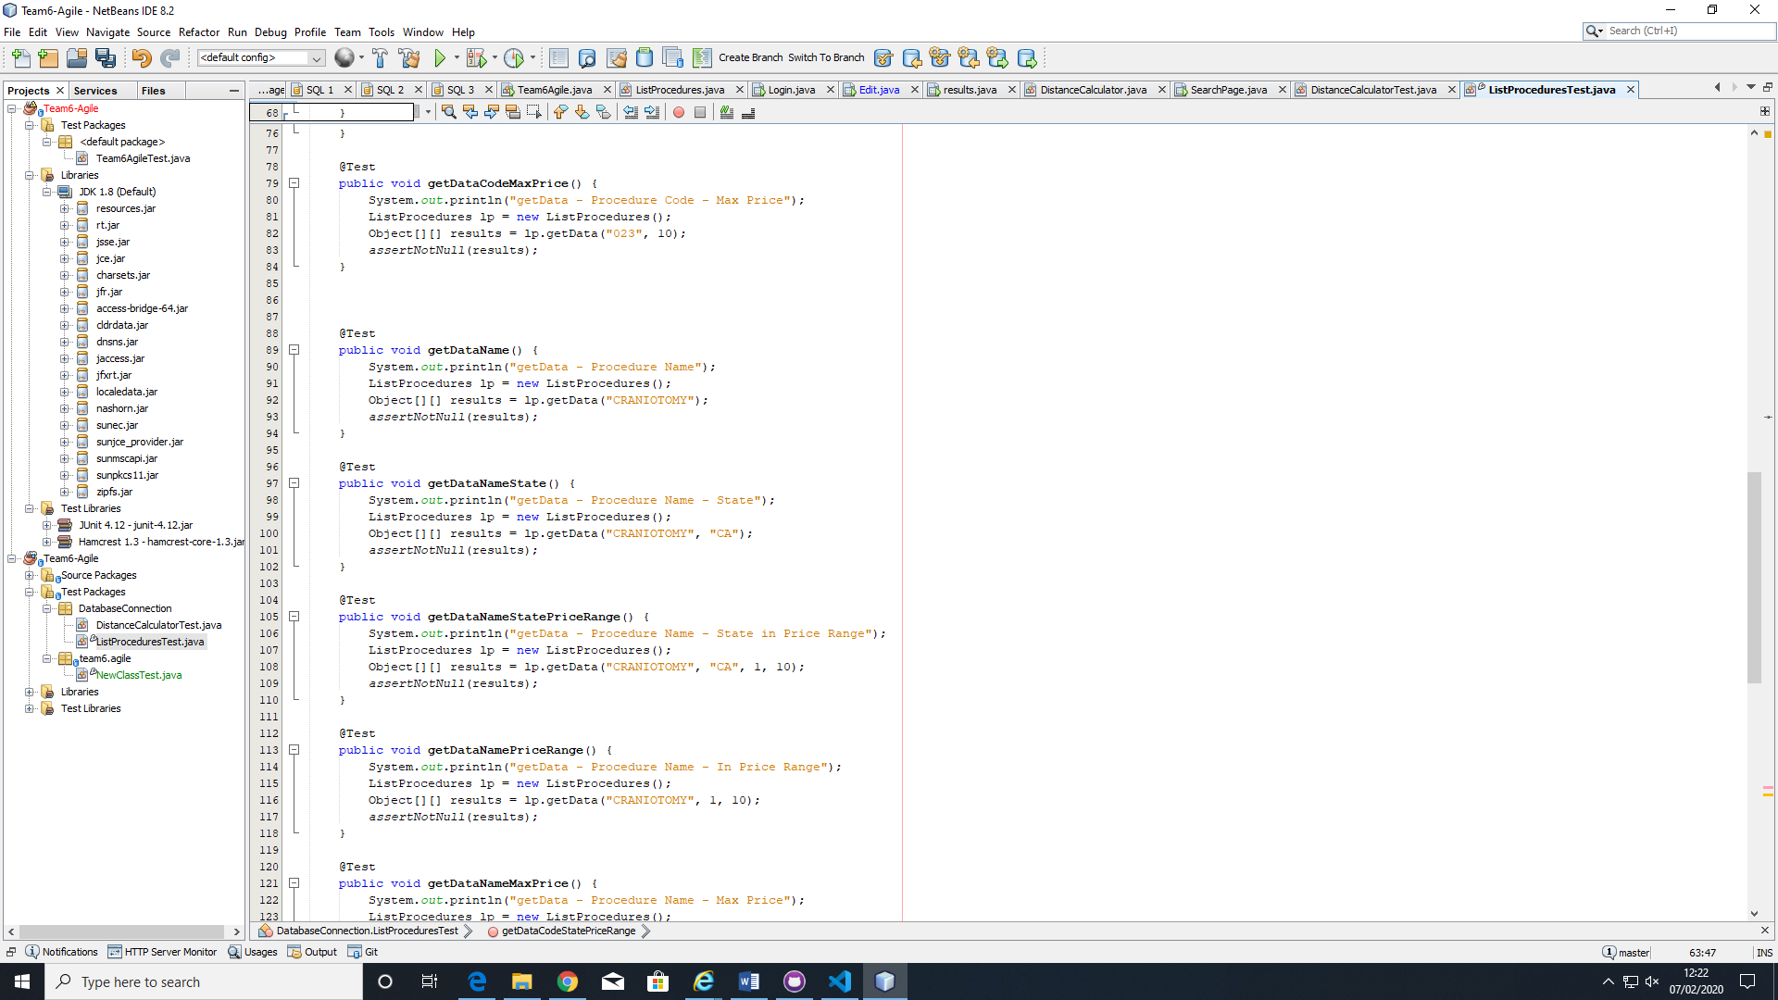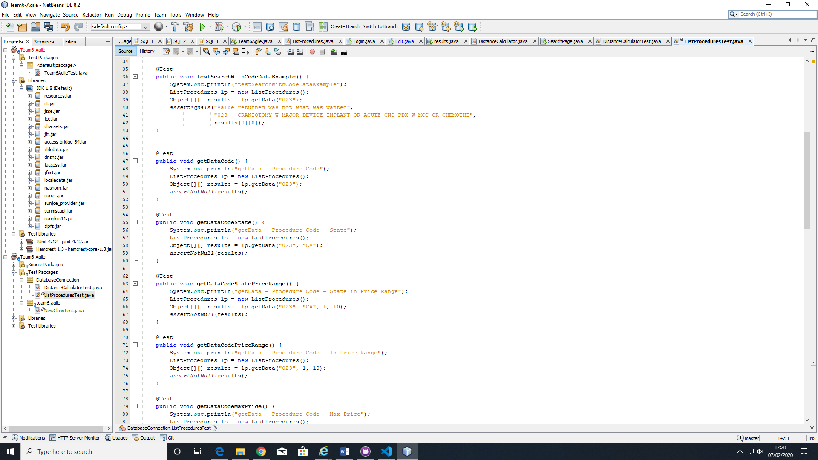**List Procedure Test Testing**